**Salesforce registration**

**Added on June 19, 2018.**

1. To register an account you need to go to https://developer.salesforce.com and click on the signup button.

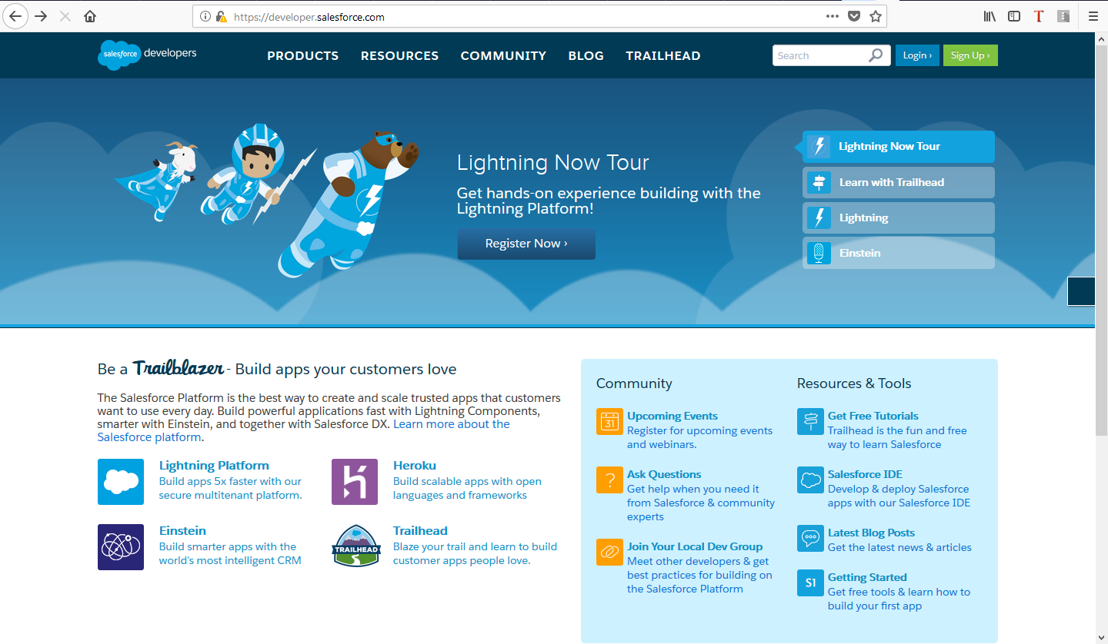

2. Fill out the form data and click on the button Sign me up.

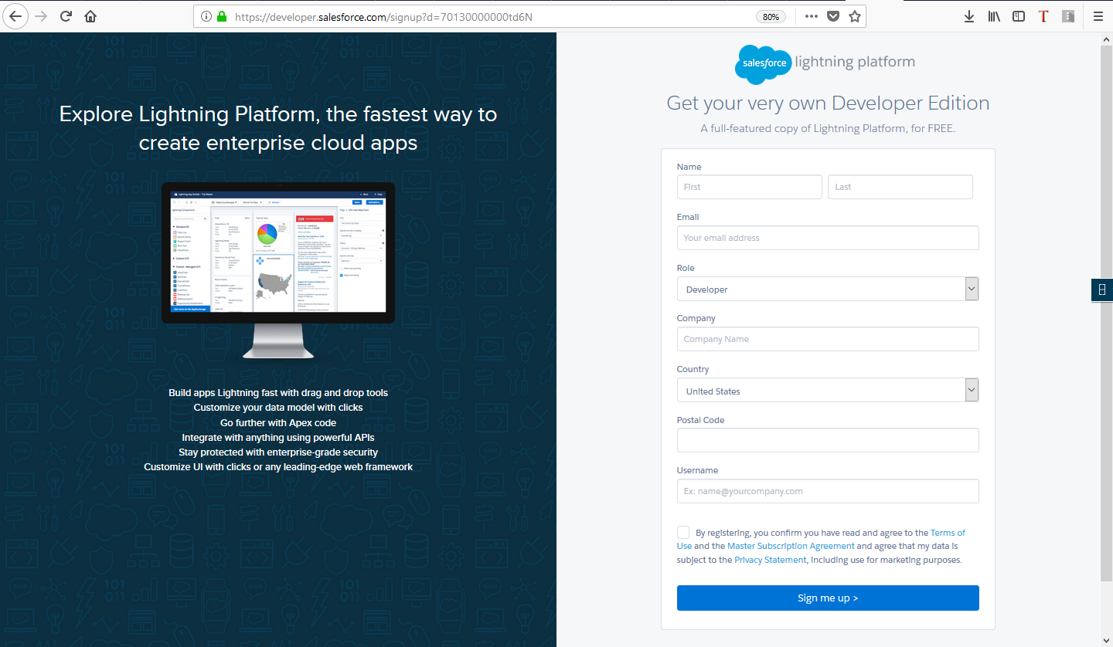

3. Confirm registration via e-mail.

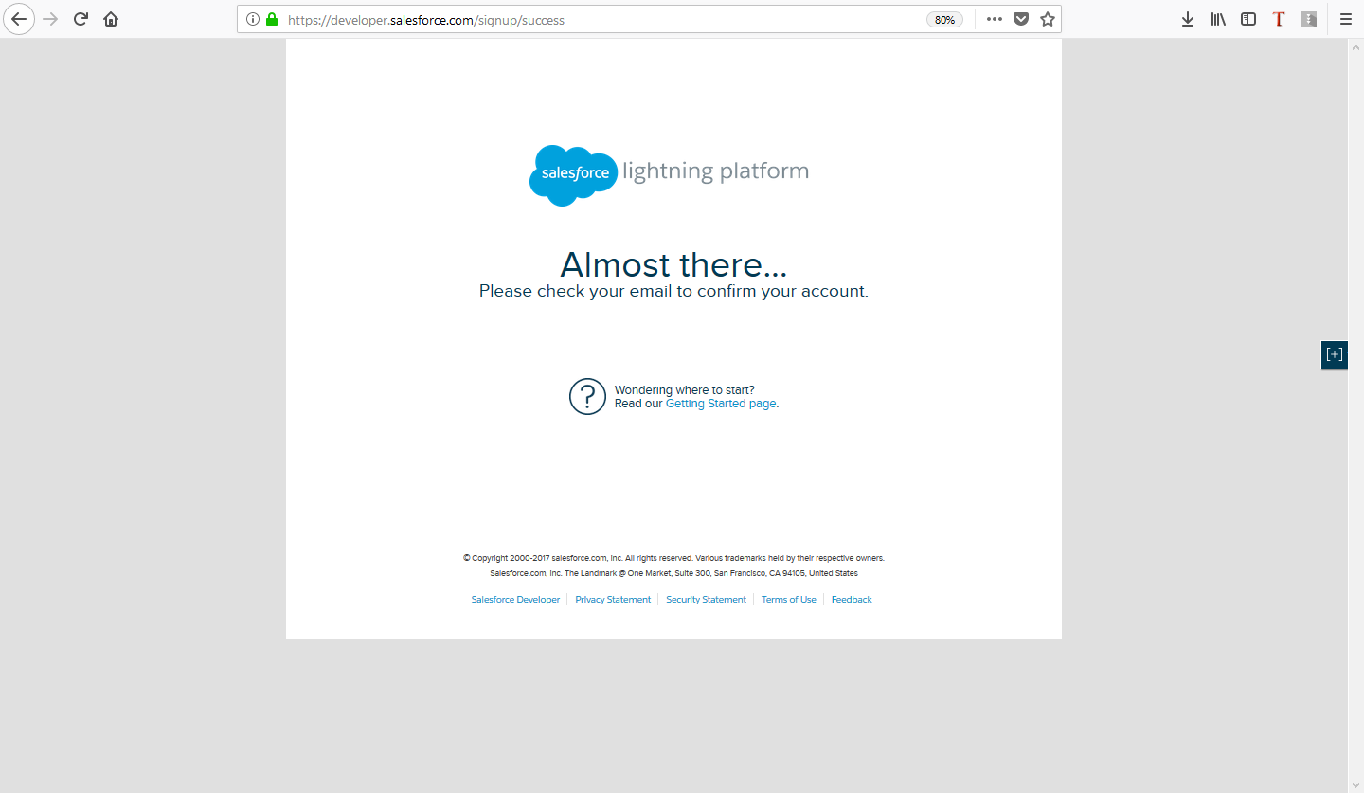

3. After registration, go to the Platform Tools and the Apps → App Manager.

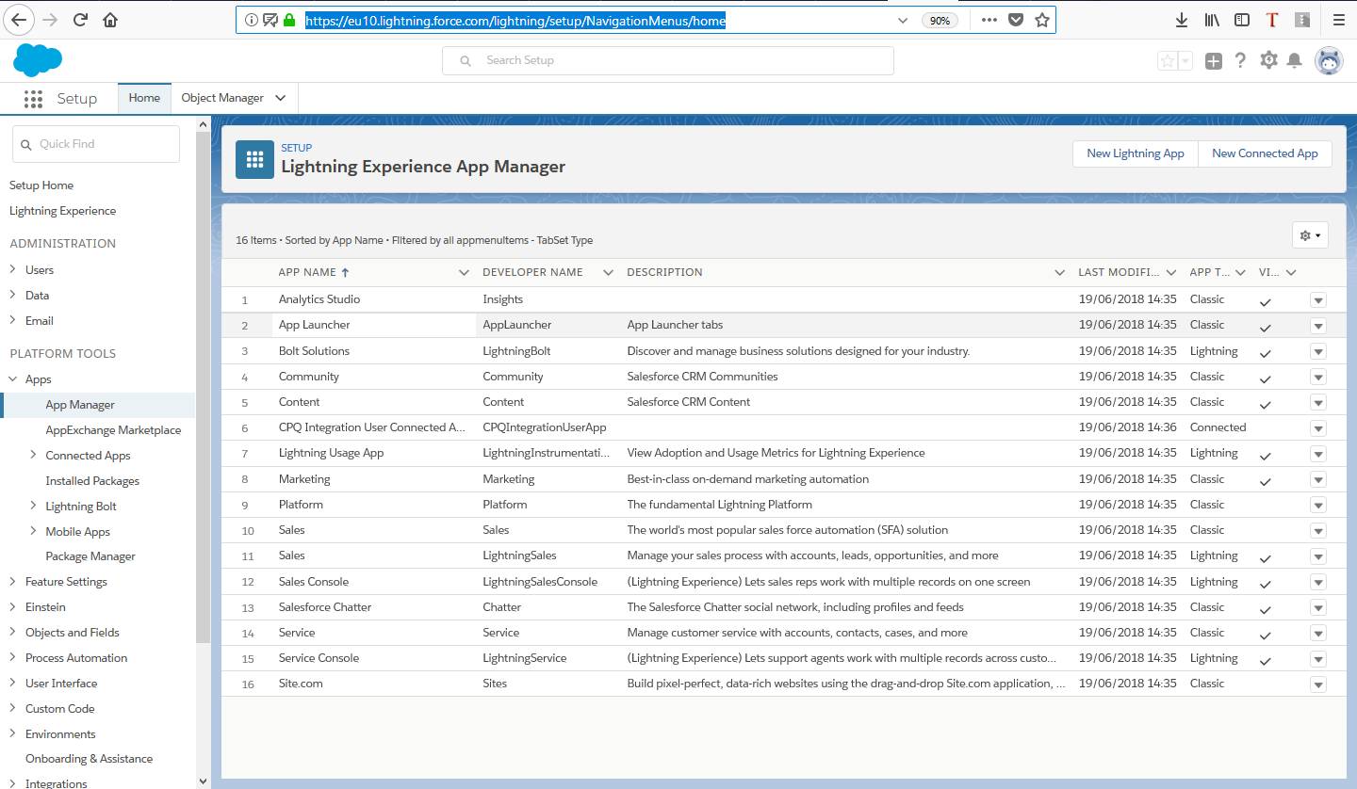

4. Click on the "New Connected App" button and fill in the application description.

To support OAuth authentication, also select the Enable OAuth Settings check box and add a list of servers for authorization in the Callback URL. Just select from the list of Scopes to which you want to share. After filling in the data, click the Save button, and then click the Continue button.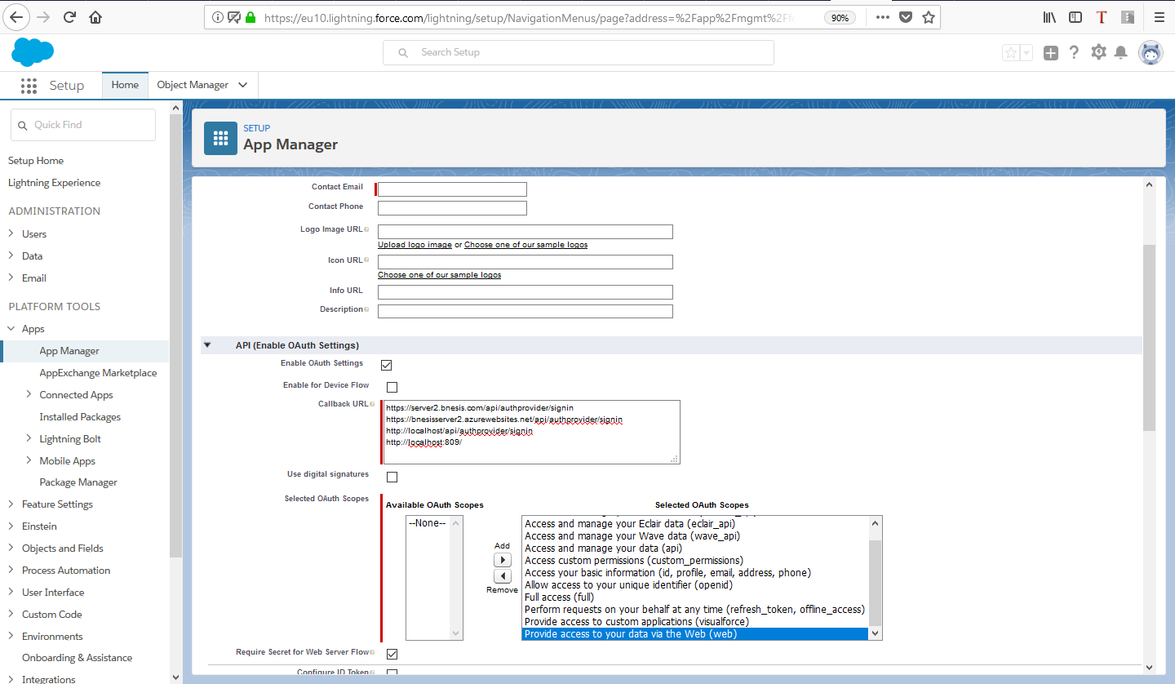

5. In the opened window you can get the necessary data for authorization and use of the API of the service (Consumer Key and Consumer Secret). Consumer Secret can be obtained after clicking on Click to reveal.

